Exercises

# **Premise:**

* You can use whatever online help or external source you desire, please add a citation about it.
* You can contact whoever you want asking for help, please give an indication about the source you contacted.
* Reply preferably in English but native language is also accepted.

# Generate PRBS and apply filter

1. Generate PRBS 13 signal in PAM4 using python with Vpeak = 0.4V and Freq=10GHz
2. Apply filter to the signal using following transfer function and plot the output signal in time domain:

H(s) = 1/(1+2*ξ*jω/ω_cut+(jω/ω_cut)^2)

Where:

ξ= 0.68

f = 10GHz

ω_cut = 2*π*f

# Feedback theory

1. Simulate a control loop in python for a temperature chamber where t_initial = 0C and t_desired = 100C. Use proportional control only.
2. Explain the problems that the loop has.
3. How can the loop control can be improved?

# Decision making

Company ACME Inc has 3 work centers A B C. Each work center costs 30Euro/h. The company produce 1 product called <<Blue>> with the current resource allocation profile. Work centers are paid with standard contract yearly wage.

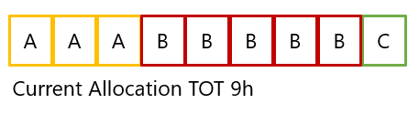

Contribution margin [1] for 1 product is 25Euro and the average demand from market is 40Units per month. (assume 160h of work in a month)

Company has 2 proposals from 2 engineers X and Y to improve current production rate.

X Improve resource A sparing 2 h and reducing the overall time to 7H.   
Implementation cost is 5000 Euro  
The cost per unit is reduced from 270Euro to 210Euro, computed as operational cost divided per unit.

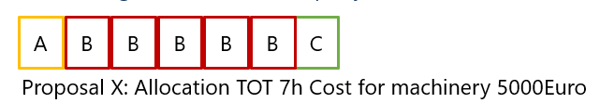

Y use resource C to do part of the job of B, reducing B time by 1h, increasing total time to 10H. Implementation cost is 0K  
The cost per unit is increased to 300Euro

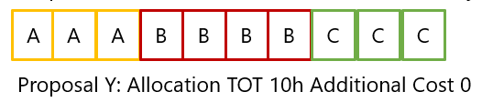

Which solution will produce the best overall results long term for the company? Why?

# Digital Signal Processing

What are the 2 fundamental digital blocks for a digital downconversion?

Using a tool of choice (Matlab, Python, LabVIEW, Online) design an efficient filter for a digital down conversion from 100MSPS to 2MSPS. Provide a description of the design choices, for example FIR, IIR, Number of stages, architecture with or without CIC.

What is the reason why the bitness (i.e. 16Bit) from input to output can increase ( i.e. 18 Bits) ?

# Data Analysis and presentation and code

Given the data provide in the stocks_data.csv use pandas matplotlib and/or plotly to create a chart showing average, min, max price of AAPL over the latest 12 months.

Provide the code to run and create the plot.

If you don’t have python installed, you can leverage colaboratory

<https://colab.research.google.com/notebooks/intro.ipynb?utm_source=scs-index>

# Exercise on EYE diagram an data analysis

Attached is an NRZ trace (Trace_Y_After_FIR.zip) in json format of a pseudo-random electrical signal (PRBS9) with 20 samples per symbol.

It is required:

* Make a plot of the whole trace
* (Eye diagram) Make a plot of the eye of the electrical signal
* Find mean value and variance of crossing times around y=0, using the previously created plot (Eye diagram)
* (Jitter) Plot the 50 bin crossing time distribution on a symbol time

Supporting documentation

* You can find a python installer here if you need it: https://www.anaconda.com/products/individual
* PRBS: https://en.wikipedia.org/wiki/Pseudorandom_binary_sequence
* Eye diagram: https://en.wikipedia.org/wiki/Eye_pattern
* Jitter: <https://dl.cdn-anritsu.com/en-au/test-measurement/files/Application-Notes/Application-Note/MP2100A_EF3100.pdf>

# Generate clock and calculate jitter

Generate a clock source f = 100MHz and add sinusoidal phase noise to the clock with f_noise = 1MHz. Calculate the jitter of the clock affected by noise.

# Data signal Processing with real Channel and equalization

Given the channel representation with S-parameters included in the folder (tx_test_ficture.s4p) and the CTLE (Continuous Time Linear Equalizer) equation below. Find the best CTLE configuration among those in the table below that best equalize the channel.

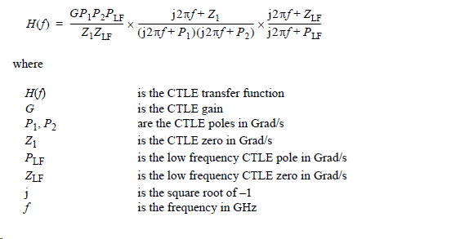

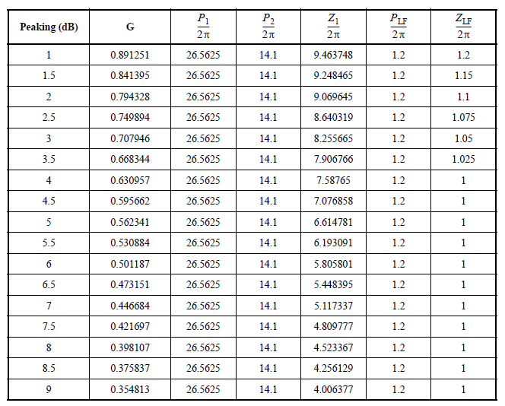

1. Contribution margin defined as (price of product sold – price of raw materials for production). Is basically the pure gross margin on product sold without taking into account operational costs.